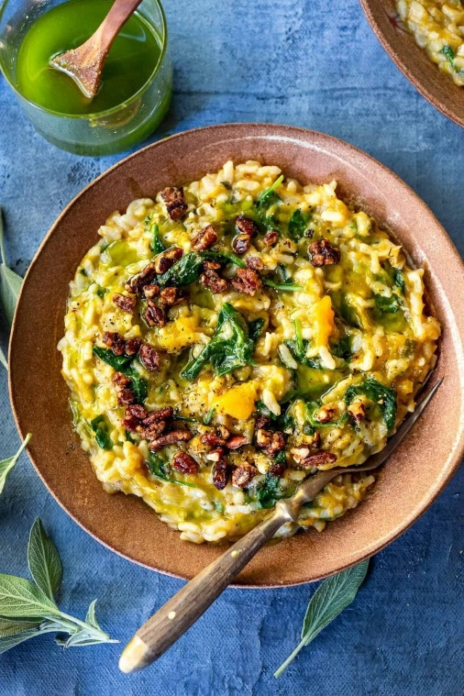**Butternut Risotto with Leeks**

**DESCRIPTION:**

Cozy up with a comforting bowl of Butternut Risotto with Leeks and Spinach made with very little fuss, in your Instant Pot pressure cooker. Vegan-adaptable and Gluten-free. Stovetop version in the notes below!

**INGREDIENTS:**

2 tablespoons olive oil (or butter)

2 cups sliced leeks (one extra large leek) or sub one onion

4 garlic cloves, rough chopped

8 sage leaves, chopped

1 cup Arborio rice or short-grain Spanish rice (Bomba)

2 heaping cups butternut squash, cubed (please see notes if making on stove top!)

1/4 cup white wine (or skip it)

2 cups veggie stock or chicken stock or broth (or water and one teaspoon or cube veggie bouillon)

1/2 teaspoon salt, more to taste

1/8 teaspoon white pepper (or sub black pepper to taste)

1/2 teaspoon nutmeg the nutmeg makes this- don’t leave it out!

2–3 handfuls baby spinach or chopped kale

OPTIONAL: 1/4 – 1/2 cup parmesan, pecorino, manchego, vegan cheese or cashew cheese – or the leave cheese out and use LEEK OIL for garnish. Or stir in 1-2 tablespoons of butter or ghee, or a drizzle of olive oil.

Optional: Maple Glazed Pecans

**INSTRUCTIONS:**

Slice and rinse leeks, separating rings (rinsing will help them to soften faster).

Set Instant Pot to the “Saute” function.

Heat oil in the instant pot, add the rinsed leeks and stir for 2 minutes. Add garlic, sage and rice, stir for 2 minutes.

Add butternut squash, and keep stirring for a couple of minutes, until there is a bit of browning on the bottom of the instant pot.

Add the wine and scrape up the browned bits- a wooden spoon is good for this. Let all the wine cook off, about 2-3 minutes. Add the stock or broth. Scrape up more browned bits. Add the salt, pepper and nutmeg, and give a good stir.

Seal the instant pot and pressure cook on HIGH for 6 minutes. Naturally, release for 5 minutes, then manually release.

While the Instant pot is going you could make the leek oil and/or the maple glazed pecans.

Stir the risotto, adding the spinach and cheese or butter if you like, or leave them out. As the butternut breaks down a bit, it will add a nice natural creaminess to the risotto.

Adjust salt to taste. If you like a “looser” risotto add a bit more broth.

Garnish with optional leek oil or maple glazed pecans.

**NUTRITION:**

Serving Size: 1 1/4 cups. Calculated with ½ cup parmesan.

Calories: 321

Sugar: 1.9g

sodium: 471.6 mg

Fat: 10.4 g

Saturated Fat: 3 g

Carbohydrates: 48.3 g

Fiber: 1.5 g

Protein: 8.1 g

Cholesterol: 7.2 mg